
QUALITY ALERT

Customer: Amerilux Date: October 10, 2024
Die: 15238 / 15191 / 15192 Colour: ALL
Type of Complaint: Amerilux REJECTED

Q.A # Q.I.R # CUSTOMER NCR #

Description: Amerilux Rejected due to bending so they are unable to put the panels together.

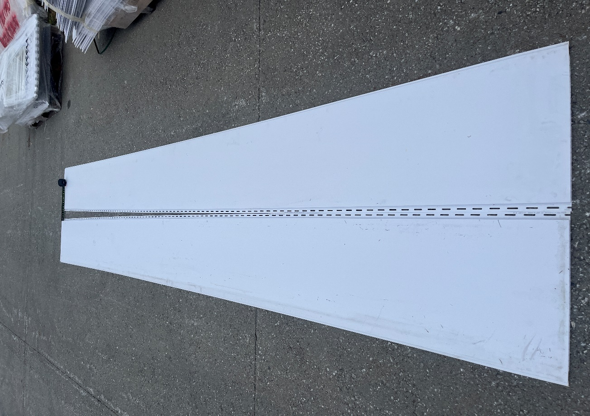
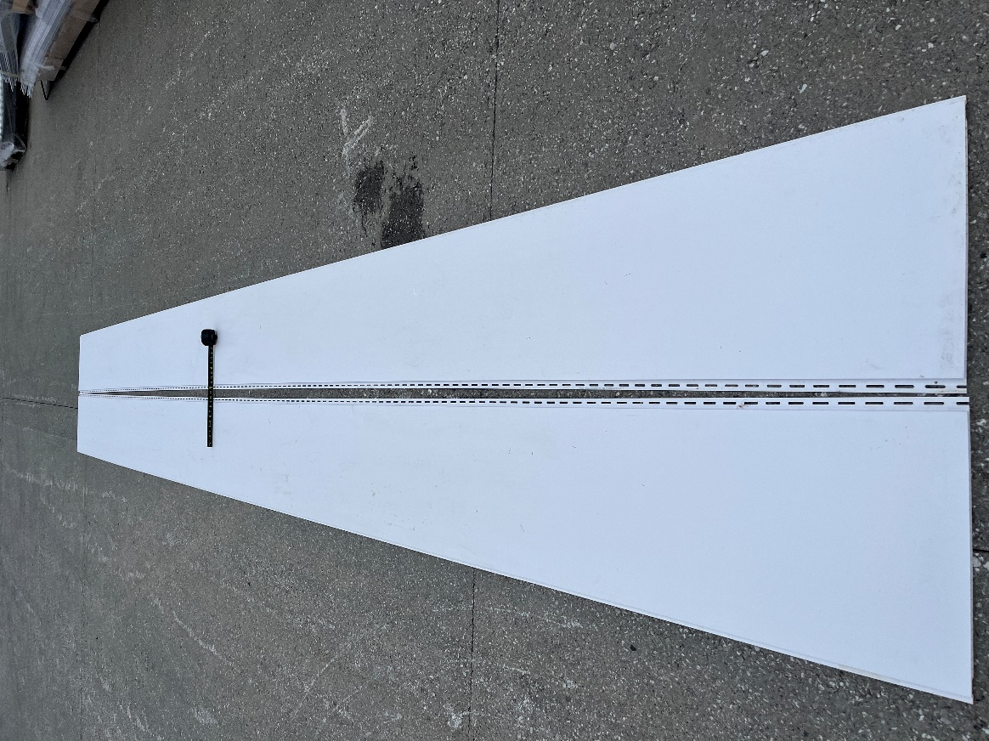

BY SIGNING BELOW, YOU ACKNOWLEDGE THE PROBLEM ABOVE AND AGREE TO MONITOR THIS ISSUE IN FUTURE PRODUCTION RUNS.
DAY SHIFT |  | AFTERNOON SHIFT |  | NIGHT SHIFT
NAME | SIGNATURE | NAME | SIGNATURE | NAME | SIGNATURE

